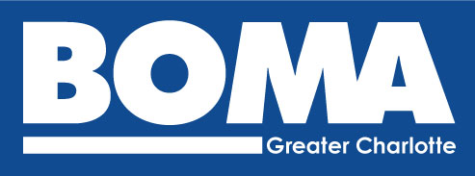

BOMA Greater Charlotte
bomagreatercharlotte.org
800.824.1677
Affiliated with BOMA International
The Outstanding Building of the Year (TOBY)
2019-2020 Entry Form

Local TOBY Submission Deadline: November 15, 2019

The mission of the TOBY award is to recognize excellence in building management, operational efficiency, tenant retention, emergency planning and community impact. The TOBY committee is charged with the mission of conducting a prestigious and impartial awards program soliciting real estate professionals the opportunity to benchmark operational excellence along with their peers located in the local, regional and international real estate industry.

Building Category: (Please see the TOBY Entry Requirements for a description of each category). You may only select one category per building entered.

Under 100,000 SF 100,000 – 249,999 SF 250,000 – 499,999 SF
500,000 – 1 million SF Over 1 million SF Corporate Facility
Earth Award Historical Building Industrial Office Building(s)
Medical Office Building Renovated Building Retail
Public Assembly Buildings Mixed-Use Category
Suburban Office Park (Low Rise) Suburban Office Park (Mid Rise)

BOMA Member Name Contact Name:
Company Name:
Phone: Email:
Building Name:
Building Address: City: State: Zip:
Building Owner:
Building Management Company:
Year Built: Year Renovated: Year Occupied: :

TOBY Award Local Entry Instructions:

Email local entry form for each submission by November 15, 2019 to: info@bomagreatercharlotte.org or Melinda.hopkins@cbre.com.

- Local building inspections will take place between December 9 and December 20, 2019
- You will be contacted 24 hours in advance of the inspection.
- Local winners will be notified by January 3, 2020.

After winning at the local level, each building will need to register on-line and submit the necessary registration fees. Information on fees, deadlines, and requirements are located at the BOMA International website. In addition, you can find the submission requirements on their Entry Requirements page.

The Regional fee of $375 ($50 for data submission and $325 entry fee) will be required before Regional submission. There is NO local fee.

Southern Regional Conference: April 2 – 5, 2020
International Conference & Expo June 27 – 30, 2020

The building must win at the local level and score a minimum of 70 points to be eligible to compete at the regional level. All regional winners will advance to the International level.

JUDGING:

A detailed inspection by a local panel of judges will be scheduled for all nominated buildings. Specific category judging forms will be e-mailed to all participants, for review, prior to the building tours. Buildings are judged on the following criteria:

- A detailed building inspection
- Tenant/employee relations
- Building accessibility
- Building personnel training
- Community impact
- Energy management systems and procedures
- Physical attractiveness

